**GPC_4T:  
MAS**

GPC_4T Micro-Level Architecture Specifications

Adi Levy ([adi.levy@campus.technion.ac.il](mailto:adi.levy@campus.technion.ac.il))

Saar Kadosh ([skadosh@campus.technion.ac.il](mailto:skadosh@campus.technion.ac.il))

Contents

1 General Description 3

1.1 High Level Definition 3

1.2 Top-Level description 3

1.3 GPC_4T Block Diagram 3

1.4 Top Level & Blocks Interface 4

2 Design Building Blocks 5

2.1 Core & Pipe Stages 5

2.1.1 Detailed Core Block Diagram 6

2.1.2 Thread Switch and Scheduler 7

2.1.3 Pipe Stages 8

2.2 I_MEM 14

2.3 I_MEM _WRAP 15

2.4 D_MEM 16

2.5 CR_MEM 18

2.6 D_MEM WRAP 19

3 Design Flows 24

3.1 Thread Freeze using CRs 24

3.2 Thread Rst using CRs 26

3.3 Multi Thread Support (Single 4 Thread Core) 27

3.4 Writing to Non-Local Memory 28

3.5 Reading from Non-Local Memory 29

Revision History

|  |  |  |  |
| --- | --- | --- | --- |
| Rev. No. | Who | Description | Rev. Date |
| 0.1 | Saar Kadosh | Initial GPC_4T MAS | 06 November 2021 |
| 0.3 | Adi Levy | fixed and detailed flows | 25 December 2021 |
|  |  |  |  |
|  |  |  |  |

Figures

[Figure 1 - GPC_4T top level block diagram 3](https://technionmail-my.sharepoint.com/personal/adi_levy_campus_technion_ac_il/Documents/GPC_4T%20MAS.docx#_Toc91955502)

[Figure 2 - Core Block diagram 6](https://technionmail-my.sharepoint.com/personal/adi_levy_campus_technion_ac_il/Documents/GPC_4T%20MAS.docx#_Toc91955503)

Figure 3 - scheduler design 7

Figure 4 - Schedulr code 7

[Figure 5 - Fetch on high level 8](https://technionmail-my.sharepoint.com/personal/adi_levy_campus_technion_ac_il/Documents/GPC_4T%20MAS.docx#_Toc91955506)

Figure 6 - The program counters 8

Figure 7 - Pc enable logic 8

[Figure 8 - Nop toggle logic 9](https://technionmail-my.sharepoint.com/personal/adi_levy_campus_technion_ac_il/Documents/GPC_4T%20MAS.docx#_Toc91955509)

[Figure 9 - Decode on high level 9](https://technionmail-my.sharepoint.com/personal/adi_levy_campus_technion_ac_il/Documents/GPC_4T%20MAS.docx#_Toc91955510)

Figure 10 - Decode logic design 10

[Figure 11 - Execute on high level 10](https://technionmail-my.sharepoint.com/personal/adi_levy_campus_technion_ac_il/Documents/GPC_4T%20MAS.docx#_Toc91955512)

Figure 12 - execute logic design 11

[Figure 13 - Mem stage on high level 12](https://technionmail-my.sharepoint.com/personal/adi_levy_campus_technion_ac_il/Documents/GPC_4T%20MAS.docx#_Toc91955514)

Figure 14 - Mem access logic design 12

[Figure 15 - Write-back on high level 13](https://technionmail-my.sharepoint.com/personal/adi_levy_campus_technion_ac_il/Documents/GPC_4T%20MAS.docx#_Toc91955516)

[Figure 16 - WB logic design 13](https://technionmail-my.sharepoint.com/personal/adi_levy_campus_technion_ac_il/Documents/GPC_4T%20MAS.docx#_Toc91955517)

Figure 17 - behavioral memorry array code 14

Figure 18 - I mem logic design 15

Figure 19 - I MEM WRAP design 16

Figure 20 - D Mem logic design 17

Figure 21 - Cr Mem logic design 19

[Figure 22 - D MEM WRAP logic design 20](https://technionmail-my.sharepoint.com/personal/adi_levy_campus_technion_ac_il/Documents/GPC_4T%20MAS.docx#_Toc91955523)

Figure 23 - Pc enable code and logic 24

Figure 24 - Cr enabler code 25

Figure 25 - freeze Pc Cr flop to core logic 25

Figure 26 - reset Pc Cr flop to core logic 27

[Figure 27 - C2F packet signals code 28](https://technionmail-my.sharepoint.com/personal/adi_levy_campus_technion_ac_il/Documents/GPC_4T%20MAS.docx#_Toc91955528)

Tables

Table 1 – GPC_4T Parameters 4

Table 2 - GPC_4T general interface 4

Table 3 - GPC_4T top interface 4

Table 4 - Core interface 5

Table 5 - Thread switch signals example 7

Table 6 - I mem interface 14

Table 7 - I Mem Wrap interface 15

Table 8 - D MEM interface 17

Table 9 - Cr Mem interface 18

Table 10 - D MEM WRAP interface 20

Table 11 - CR offsets for thread freeze 24

Table 12 - CR offsets for thread reset 26

Table 13 - C2F write request packet 28

Table 14 - C2F read request packet 29

Table 15 - C2F response packet 30

# General Description

## High Level Definition

The MAS describes the Micro-Level-Architecture of the **GPC_4T.**This is the Logic Design implementation of GPC_4T Architectonic demands described on HAS.  
This Section covers the micro architecture of the stages of the core, and the way the D_MEM_WRAP and I_MEM_WRAP interact with the core and the Fabric. The section will cover the logic design for the communication and the implementation of the GPC_4T.

## Top-Level description

The GPC_4T module is one of two main components in the LOTR Tile (the other is the Ring Controller). The module contains 3 major building blocks : **Core**(Core_4t) , **Instruction memory wrapper**(I_MEM_WRAP) and **Data memory wrapper**(D_MEM_WRAP). The inputs and outputs coming directly from 2 **Ring controller buffers** : Core to Fabric buffer (AKA **C2F**) which handle requests coming from the core to the Fabric (For example, read request from non-local memory) and Fabric to Core buffer (AKA **F2C**) which handle request coming from the Fabric to the core.

The core module doesn’t “aware” of the Ring Controllers and all the requests and responses going from the buffers to the I Mem and D Mem Wraps or vice versa. All the communication between Core and RC (Ring Controller) is done via the memory wrappers.

## GPC_4T Block Diagram

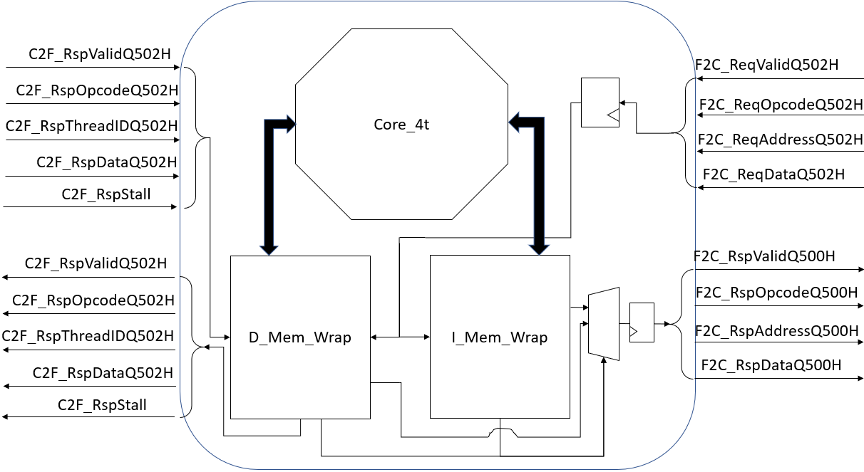

Core to Fabric buffer

Fabric to Core buffer

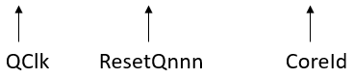

Figure 1 - GPC_4T top level block diagram

## Top Level & Blocks Interface

**Default Parameter Values:**

|  |  |  |
| --- | --- | --- |
| Name | Default | Description |
| INT_LEN | 32 | Integer Size - RV32I Spec “XLEN” |
| REGFILE_NUM | 32X4 | Number of registers in the register file - RV32I Spec is 32 for each thread |
| SIZE_I_MEM | 2^12 | Size of the instruction memory |
| LSB_I_MEM | 0 | Offset of the LSB in the I MEM |
| MSB_I_MEM | 11 | Offset of the MSB in the I MEM |
| I_MEM_OFFSET | 0x00000000 | Offset of the I mem |
| SIZE_D_MEM | 2^12 | Size of the date memory |
| LSB_D_MEM | 0 | Offset of the LSB in the D MEM |
| MSB_D_MEM | 11 | Offset of the MSB in the D MEM |
| D_MEM_OFFSET | 0x00400000 | Offset of the D mem |
| SIZE_SHRD_MEM | 2^11 | Size of shared memory |
| SIZE_MEM | 2^13 | Whole memory size |
| MSB_CR | 11 | Offset of the MSB in the CR MEM |
| LSB_REGION | 22 | LSB of the region bits on the address |
| MSB_REGION | 23 | MSB of the region bits on the address |
| I_MEM_REGION | 00 | I mem region bits |
| D_MEM_REGION | 01 | D mem region bits |
| CR_REGION | 11 | CR region bits |
| LSB_CORE_ID | 24 | LSB of the Core id bits on the address |
| MSB_CORE_ID | 31 | MSB of the Core id bits on the address |
| THREAD0_STACK_BASE | 0x400200 | Thread 0 stack pointer base offset |
| THREAD1_STACK_BASE | 0x400400 | Thread 1 stack pointer base offset |
| THREAD2_STACK_BASE | 0x400600 | Thread 2 stack pointer base offset |
| THREAD3_STACK_BASE | 0x400800 | Thread 3 stack pointer base offset |

Table 1 – GPC_4T Parameters

**General interface signals:**

|  |  |  |  |
| --- | --- | --- | --- |
| Name | Size | Direction | Description |
| QClk | 1 | Input | Q Clock – a single clock domain. |
| RstQnnnH | 1 | Input | Active High Reset |
| CoreID | 8 | input | Contains a unique Core Id number from the LOTR Tile |

Table 2 - GPC_4T general interface

**GPC_4T To Fabric Interface:**

|  |  |  |  |
| --- | --- | --- | --- |
| Name | Size | Direction | Description |
| Fabric to Core | | | |
| F2C_ReqValidQ502H | 1 | Input | The data entering the GPC_4T is a Req. |
| F2C_ReqOpcodeQ502H | 1 | Input | Opcode of the Req that is passed from the Fabric: RD or WR. |
| F2C_ReqAddressQ502H | 32 | Input | The address of the Req in the destination core. |
| F2C_ReqDataQ502H | 32 | Input | Data to be written in the destination core (when WR). |
| F2C_RspValidQ500H | 1 | output | The data leaving to the Fabric is a Rsp. |
| F2C_RspOpcodeQ500H | 1 | output | Opcode of the Rsp that is passed to the Fabric: RD or WR. |
| F2C_RspAddressQ500H | 32 | output | The address of the Rsp in the destination core. |
| F2C_RspDataQ500H | 32 | output | Data to be written in the destination core (when WR). |
| Core to Fabric | | | |
| C2F_RspValidQ502H | 1 | input | The data entering from the Fabric is a Rsp. |
| C2F_RspOpcodeQ502H | 1 | Input | Opcode of the entering Rsp that is entering from the Fabric: RD or WR. |
| C2F_RspThreadIDQ502H | 2 | Input | The destination thread of the entering Rsp. |
| C2F_RspDataQ502H | 32 | Input | Data that was requested by the original Req. |
| C2F_Stall | 1 | Input | When ‘1’, Core does not send out Reqs |
| C2F_ReqValidQ500H | 1 | output | The data leaving to the Fabric is a Req. |
| C2F_ReqOpcodeQ500H | 1 | output | Opcode of the Req that is passed to the Fabric: RD or WR. |
| C2F_ReqThreadIDQ500H | 2 | output | The thread sending the Req. |
| C2F_ReqAddressQ500H | 32 | output | The address of the Req in the destination core. |
| C2F_ReqDataQ500H | 32 | output | Data to be written in the destination core (when WR). |

Table 3 - GPC_4T top interface

# Design Building Blocks

## Core & Pipe Stages

The core (AKA Core_4t) is one of the main building blocks of GPC_4T. The cores task is to run and execute the program instructions. The gpc_4t core supports 4 hardware threads simultaneously, each has unique Pc (Program counter), unique register files (each with 32 registers capable holding 32bit integer value) and unique data memory region for its stack pointer. The core is in order pipeline architecture with 5 stages. The MAS covers the core stages along with the logic and interface with the other components of the GPC_4T. A better description of the core will be to describe each pipeline stage separately.

Core Interface:

|  |  |  |  |
| --- | --- | --- | --- |
| Name | Size | Direction | Description |
| Instruction Output | | | |
| PcQ100H | 32 | output | PC that leaves to the I_MEM from Fetch stage |
| MemAdrsQ103H | 32 | output | Memory address that leaves to D_MEM from Memory Access stage |
| MemWrDataQ103H | 32 | output | Data that leaves to D_MEM from Memory Access stage |
| CtrlMemWrQ103H | 1 | output | WR indication bite that leaves to D_MEM from Memory Access stage |
| CtrlMemRdQ103H | 1 | output | RD indication bite that leaves to D_MEM from Memory Access stage |
| MemByteEnQ103H | 4 | output | Memory access indication according to Funct3 of the Opcode |
| ThreadQ103H | 4 | output | Thread sending the request |
| PcQ103H | 32 | output | Go to D Mem Wrap as CR Mem input |
| Instruction Input | | | |
| QClk | 1 | input | Clock signal |
| RstQnnnH | 1 | Input | Reset signal to stop Thread cycle |
| InstFetchQ101H | 32 | Input | Instruction received from I_MEM at Decode stage |
| MemRdDataQ104H | 32 | Input | Data requested at Memory Access stage received from D_MEM at Write Back stage |
| C2F_RspMatchQ104H | 1 | Input | Data requested at Memory Access stage from different GPC_4T memory received from D_MEM at Write Back stage. |
| T[i]RcAccess | 1 | Input | Comes from D MEM WRAP to freeze thread i PC if accessed non-local memory |

Table 4 - Core interface

### Detailed Core Block Diagram

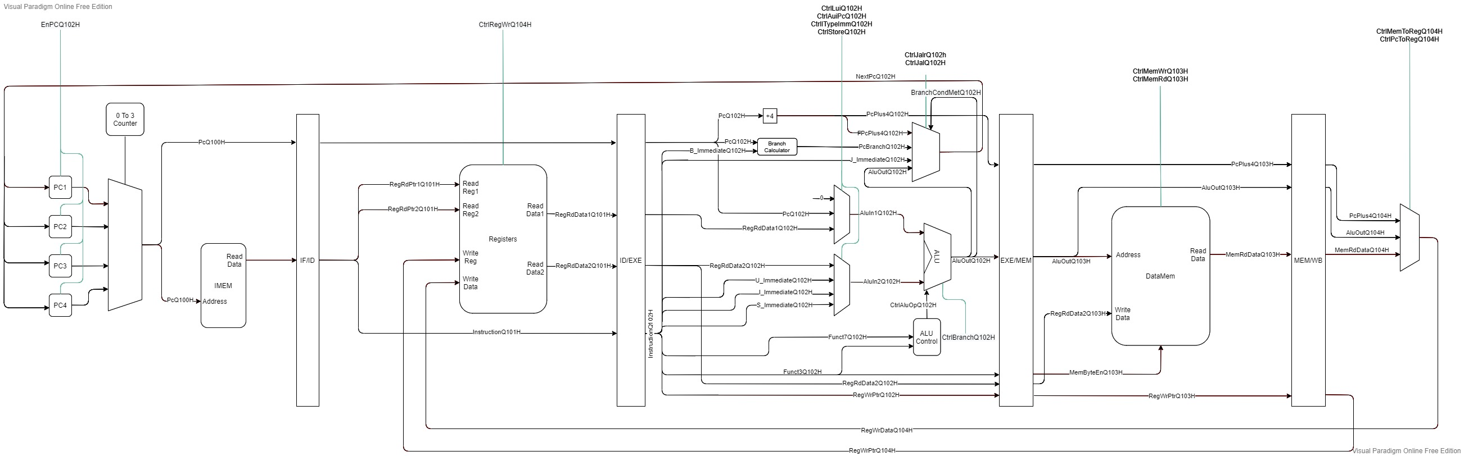

Figure 2 - Core Block diagram

### Thread Switch and Scheduler

Before the pipe stages, or more abstract, above all the pipeline, is the logic that determine the threads scheduler. Each thread is decoded as a 4 bits number – 0001 , 0010 , 0100 , 1000 for thread 0, 1, 2, 3 respectively.  
Five signals, one for each pipe stage, holding the thread number currently in this stage. For example, ThreadQ100H will hold 1000 means that thread 3 currently in stage Q100H which means that ThreadQ101H will hold 0100 and ThreadQ102H will hold 0010 ,etc.  
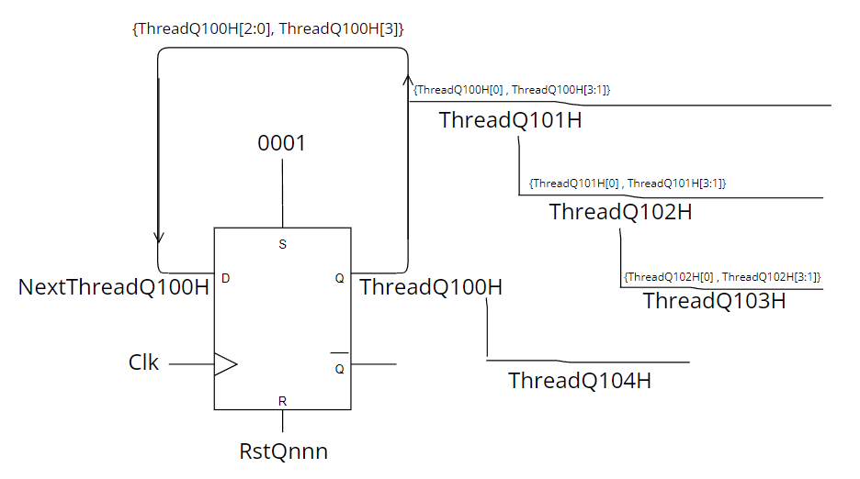

Figure - scheduler design

The scheduler is implemented with a **shift register** flop with a "reset value" = 0001, input NextThreadQ100H and output ThreadQ100H.  
At first ThreadQ100H will hold reset value 0001. with the implementation logic, NextThreadQ100H will get the 3 LSB of ThreadQ100H as its MSB and will hold the value "0010" which is the next thread that will run on stage Q100H in the next cycle.  
With some bitwise shifting, ThreadQ101H, ThreadQ102H and ThreadQ103H will get the values 1000 , 0100 ,0010.   
On the next cycle, ThreadQ100H will get the value 0010 and NextThreadQ100H with the shift register will get 0100 and so on. 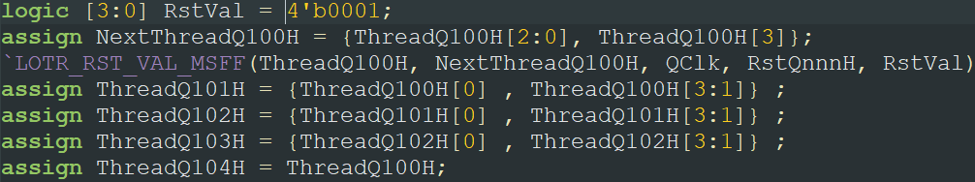

Figure - Schedulr code

|  |  |  |  |  |  |
| --- | --- | --- | --- | --- | --- |
|  | Q100H | Q101H | Q102H | Q103H | Q104H |
| cycle 0 | 0001 |  |  |  |  |
| cycle 1 | 0010 | 0001 |  |  |  |
| cycle 2 | 0100 | 0010 | 0001 |  |  |
| cycle 3 | 1000 | 0100 | 0010 | 0001 |  |
| cycle 4 | 0001 | 1000 | 0100 | 0010 | 0001 |
| cycle 5 | 0010 | 0001 | 1000 | 0100 | 0010 |
| cycle 6 | 0100 | 0010 | 0001 | 1000 | 0100 |

Table 5 - Thread switch signals example

### Pipe Stages

#### Fetch

Figure - Fetch on high level

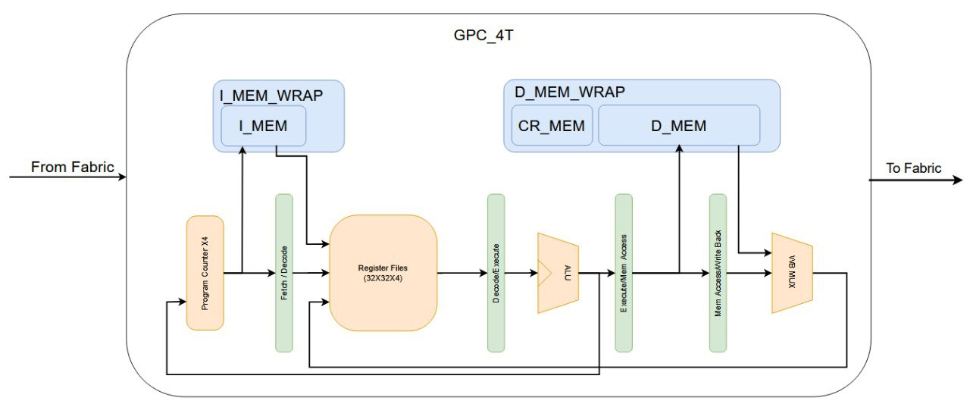

Fetch stage first "job" is to maintain 4 separate program counters, one for each thread.

Figure - The program counters

Each PC is fed by a signal "NextPcQ102H" will implies that the **next Pc for a thread is determined on stage Q102H.**The "enable" for each PC is toggled by this logic:  
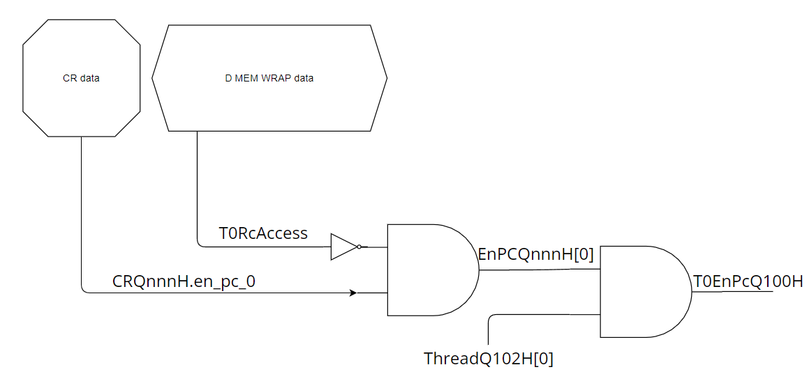

Figure - Pc enable logic

Each Pc is sampling only if ThreadQ102H[i] is `1, impling that thread currnetly on Q102H is this thread – therfore the thread's PC will hold the same value for 3 cycles, until it reaches Q102H and the enable will toggle on and it will sample new next value.

all PCs are connected to MUX that will control the signal PcQ100H. The output of the MUX will be determine by the thread currently runs on stage Q100H.

The second importand role for this stage is to take the PcQ100H signal to the I Mem Wrap and to the instruction memory as the address of the instruction in the I_MEM.

in addition, Nop injection logic is defined in this stage:

Figure - Nop toggle logic

if current thread running on this stage is also disabled by CR Mem(software freeze) or D Mem wrap (hardware freeze by accessing to non-local memory), Nop control signal will toggled and will bubble until stage Q101H there the Decode stage will inject a "nop" instruction instead of a regular instruction. The signal will continue to Q102H and will connect to the PC as another enable signal.

#### Decode

Figure - Decode on high level



Decode stage is the pipe stage on which the 32bit encoded instruction arrived from the instruction memory is decoded. All relevant data from the instruction including registers numbers and OpCode control signals is extracts from the instruction fetched. For example, if 7 LSBits of the instruction, which are the OpCode, are 0000011, then it means this is load instruction and the signal **CtrlMemRdQ101H** is set to `1.

the stage logic design:

Figure - Decode logic design

4 different register files for each thread, each with 32 registers that can save 32bit integer.  
Data from designated registers(as in the instruction) is read simultaneously from all threads designated registers, and 2 Mux units determine which the output by the thread currently runs on Q101H.  
output determined by the Mux units is the registers data that will be transferred to the next pipe stage as RegRdData1Q101H and RegRdData2Q101H.  
The control signals are toggled by the data extracted from the instruction, with the OPCODE data and funct3 and funct7 data decode.  
All the control signals are sampled from SignalQ101H to SignalQ102H to the next pipe stage.

#### Execute



Figure - Execute on high level

The Execution stage contains all the components that calculate values. In this stage all the arithmetic calculation are initiate, branch resolution is made and the next PC for current thread is determined. in addition the instruction data (now at InstructionQ102H) is passing another decode and broken down into the Immediates, funct3, and funct7.

The stage logic design:

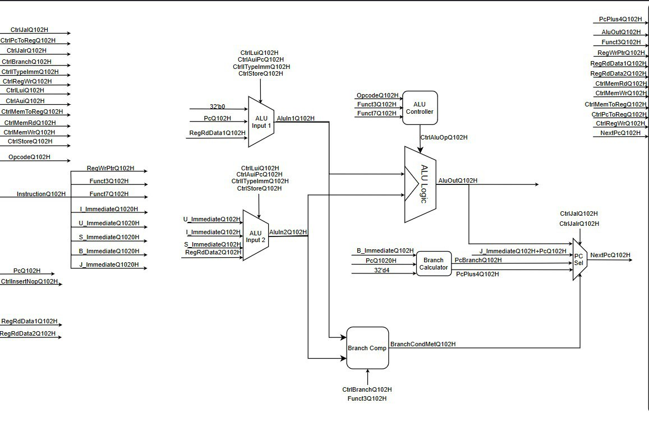

Figure - execute logic design

Branch Calculator: calculate the 2 possible next PCs of the thread: PcPlus4Q102H=PcQ1020H+ 32'd4 and PcBranchQ102H= B_ImmediateQ102H+PcQ1020H. The new value for the next PC is chosen in the PS select component.

ALU Input 1 and ALU input 2 MUXs: selecting the correct inputs to the ALU using CtrlLuiQ102H, CtrlAuiPcQ102H, CtrlITypeImmQ102H and CtrlStoreQ102H as the select for both MUXs. ALU Input 1 selects between RegRdData1Q102H, PcQ102H and 32’b0 and ALU Input 2 selects between the Immediates (U,I,S) and RegRdData2Q102H. the outputs of the MUXs are AluIn1Q102H and AluIn2Q102H.

Branch Comparator: when a branch instruction is inserted, the inputs of the branch comparator (AluIn1Q102H and AluIn2Q102H) are the values to compare. Based on funct3 to decide which condition is to be set, BranchCondMetQ102H gets the correct value.

ALU Controller: based on funct3, funct7 and the opcode, will set a value to CtrlAluOpQ102H that will enter the ALU and decide the operation.

ALU Logic: the actual computational component. Will get AluIn1Q102H and AluIn2Q102H as inputs and according to CtrlAluOpQ102H will calculate the value for AluOutQ102H.

PC Sel: decides the next value for PC among the 4 options: PcBranchQ102H calculated by the Branch Calculator, PcPlus4Q102H also calculated by the Branch Calculator, AluOutQ102H calculated in the ALU and J_ImmediateQ102H+PcQ102H that is the address to jump if the instruction is a Non-Conditional Branch. Using CtrlJalrQ102H, CtrlJalQ102H  
and BranchCondMetQ102H as the select the chosen PC (NextPcQ102H) is passed to the four PCs in the Instruction Fetch stage and is updated using the indicated from Q102H (the Execute stage).

#### Memory

Figure - Mem stage on high level



The memory stage doesn't contain much logic in the core. the main idea in this stage is the data memory transaction. The data memory is accessed to read from or write to. A **writable data** from the registers is assign on the signal "MemWrDataQ103H" and an **address** to read from in the memory is assign to signal "MemAdrsQ103H", both as the outputs to the data memory, and control signals implying read enable or write enable (or neither) is also assign to data mem. PcQ103H signal is also leave the core to the data memory wrapper in order to implement certain logic. The MUX output MemByteEnQ103H is selected by Funct3Q103H[1:0] from 4 possible inputs: 'b0001 (LB/SB), 'b0011(LH/SH), 'b1111(LW/SW) or 'b0000.

MemRdDataQ103

D MEM WRAP

Figure - Mem access logic design

#### Write Back



Figure - Write-back on high level

The Write Back stage selects the correct data to be passed and written at the thread register file. Once the instruction was executed, the new might be written to the register file. The candidates for the data are PcPlus4Q104H (PC+4 for jump and link command), MemRdDataQ104H (data read from memory) or AluOutQ104H(ALU calculation result) . Using CtrlMemToRegQ104H, CtrlPcToRegQ104H and C2F_RspMatchQ104H the correct input is selected (RegWrDataQ104H) and using ThreadQ104H, RegWrDataQ104H is directed to the threads register file. The register files default behavior is to keep the old value and not update, unless CtrlRegWrQ104H is set to ‘1’ and the register file will read the data in RegWrDataQ104H and update.

Figure - WB logic design

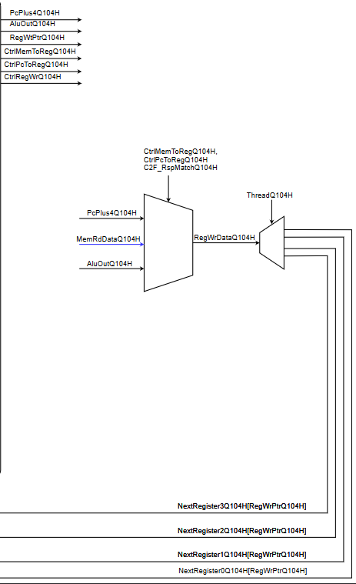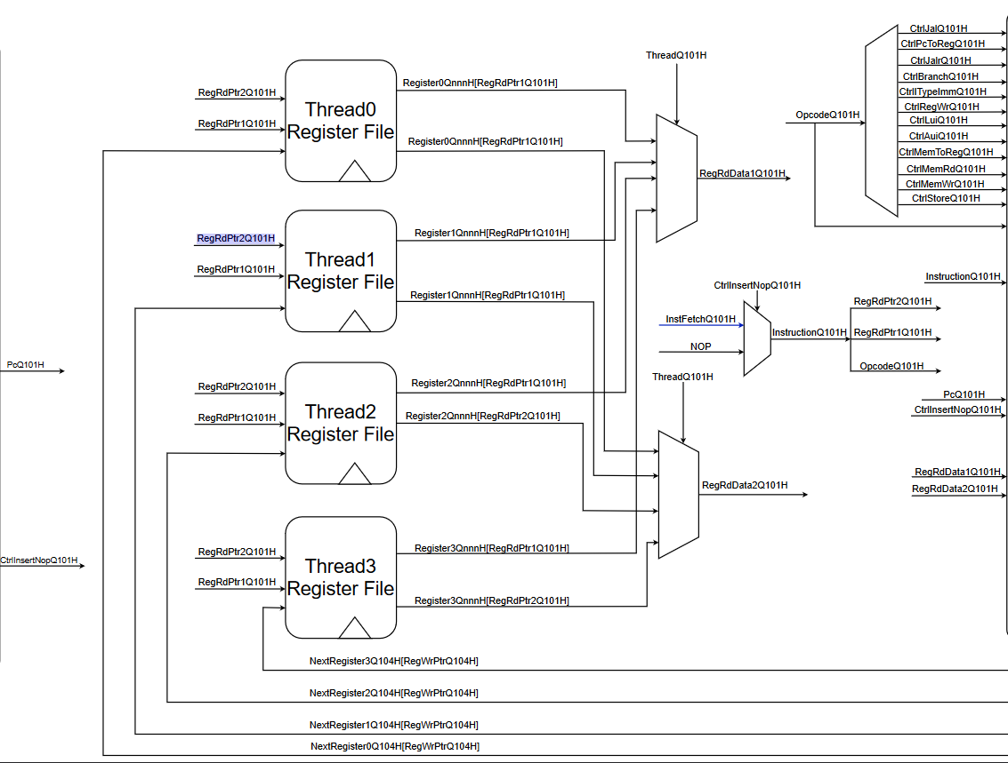

## I_MEM

The I_MEM is the memory module that contains the code of the program. The module is S-RAM based and can contain up to 4KB of instructions by default and defined in the addresses 0x00000000 – 0x00000FFF.  
The I Mem is dual port – it contains separate inputs and outputs for both GPC_4t Core and the Ring Controller. In our design the core can only read instructions and the Rc can only write instructions. Its important to mention that in this design, we implemented the memory itself as a behavioral memory, which simulates the behavior of a physical memory. We used an array on the Verilog code and in the future synthesis plans, it will be replaced with FPGA supported design.  
2 flops, one for each interface are sampling the memory instruction data at the input address for each interface (core with PC as address). The output of the Core interface flop is the instruction fetched. All the behavioral memory array also sampled in a flop.

|  |  |  |  |
| --- | --- | --- | --- |
| Name | Size | Direction | Description |
| QClk | 1 | input | Clock signal |
| RstQnnnH | 1 | Input | Reset signal |
| Core Interface | | | |
| address_a | 32 | input | usually, the Pc of a thread from the core used as the address |
| data_a | 32 | input | data to be written by the core,usually `0. not in use |
| rden_a | 1 | input | read enable bit from the core, usually `1 |
| wren_a | 1 | input | write enable from the core, usually `0 .not in use |
| q_a | 32 | output | data(instruction) sampled from i mem array to the core |
| RC interface | | | |
| address_b | 32 | input | address from Rc |
| data_b | 32 | input | data to be written by the Rc |
| rden_b | 1 | input | read enable bit from the Rc, usually `0. not in use |
| wren_b | 1 | input | write enable from the Rc |
| q_b | 32 | output | data(instruction) sampled from i mem array to the Rc |

Table 6 - I mem interface

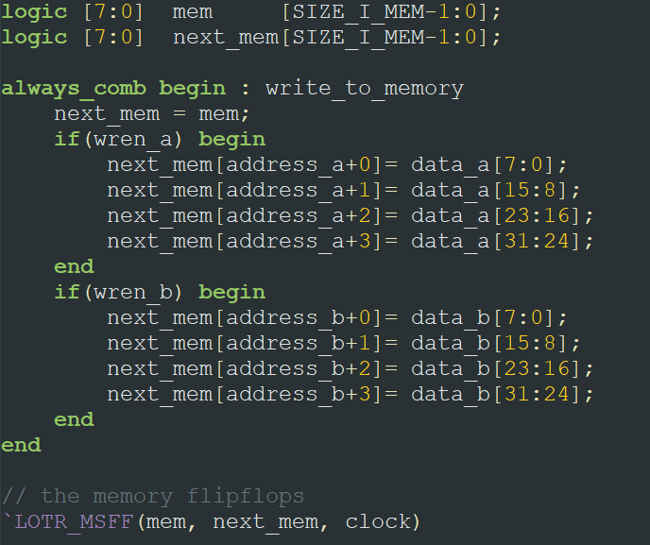

Figure - behavioral memorry array code

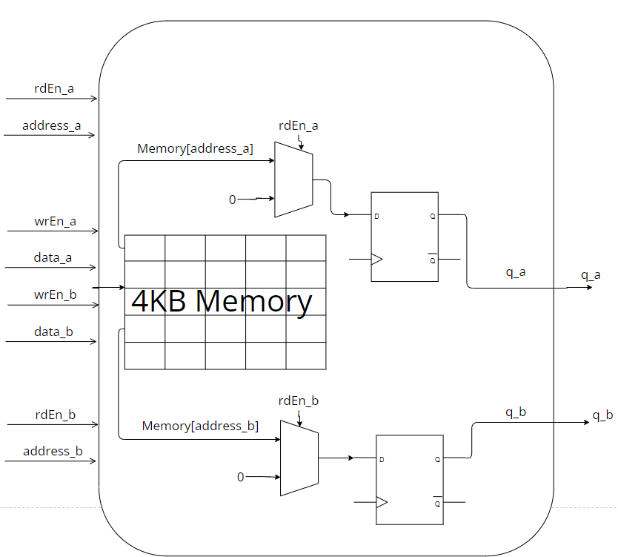

Figure - I mem logic design

## I_MEM _WRAP

The I mem wrap is the module wrapping the I mem module and is integrated to the core in the GPC_4T design. Using this module, the core can "talk" with the real instruction memory and this is the unit that connects with the core. This module simply instantiate the I Mem module, and also implements Fabric To Core logic for Ring controller interaction.  
I_MEM_WRAP Interface:

|  |  |  |  |
| --- | --- | --- | --- |
| Name | Size | Direction | Description |
| QClk | 1 | input | Clock signal |
| RstQnnnH | 1 | Input | Reset signal |
| Core interface | | | |
| PcQ100H | 32 | Input | PC from the core of the requested instruction |
| RdEnableQ100H | 1 | Input | RD enable bit for the I_MEM RD validation |
| InstFetchQ101H | 32 | output | Requested instruction |
| Ring interface | | | |
| F2C_RspIMemValidQ504H | 1 | output | Validation bit indicating a valid Rsp to a Fabric Req |
| F2C_I_MemRspDataQ504H | 32 | output | Rsp to a Fabric Req |
| F2C_ReqValidQ503H | 1 | Input | Validation for a Req from the Fabric |
| F2C_ReqOpcodeQ503H | 1 | Input | Opcode of a Req from the Fabric |
| F2C_ReqAddressQ503H | 32 | Input | Address of a Req from the Fabric |
| F2C_ReqDataQ503H | 32 | Input | Data of a Req from the Fabric |

Table 7 - I Mem Wrap interface

Figure - I MEM WRAP design

Fabric to Core request flow:

Fabric Req: any communication between the I_MEM and the Fabric is done through using the I_MEM Fabric Interface logic. The logic checks if the Req is I_MEM Req by comparing F2C_ReqAddressQ503H[MSB_REGION:LSB_REGION] to I_MEM_REGION, checking the opcode F2C_ReqOpcodeQ503H (RD or WR) and checking for the validation bit of the Req F2C_ReqValidQ503H. once the Req is valid and the type is chosen, I_MEM receive F2C_ReqAddressQ503H[MSB_I_MEM:0], F2C_RdEnQ503H, F2C_WrEnQ503H (and F2C_ReqDataQ503H if WR). If the Req is WR, the data is written to the relevant address, else the Req is RD and a Rsp leaves I_MEM to the Fabric as a Rsp via F2C_I_MemRspDataQ504H and a valid bit for the Rsp F2C_RspIMemValidQ504H.

Core request flow:

Core Req: The request from the core is the typical instruction request. PcQ100H[MSB_I_MEM:0] is sent to I_MEM along with RdEnableQ100H from the Fetch Stage. The instruction of the thread leaves I_MEM as InstFetchQ101H to enter the core at the Decode Stage.

## D_MEM

D_MEM is the memory module that contains the data of the program. The module is S-RAM based and can contain up to 4KB of data by default and defined in the addresses 0x00400000 – 0x00400FFF and its very similar to the I MEM.  
The D Mem is dual port – it contains separate inputs and outputs for both GPC_4t Core and the Ring Controller. In our design the core can read and write data to the D Mem and the RC can do the same. Like on the I MEM, it's important to mention that in this design, we implemented the memory itself as a behavioral memory, which simulates the behavior of a physical memory. We used an array on the Verilog code and in the future synthesis plans, it will be replaced with FPGA supported design.  
2 flops, one for each interface are sampling the memory instruction data at the input address for each interface (core with PC as address). The output of the Core interface flop is the instruction fetched. All the behavioral memory array also sampled in a flop.

On our Validation plan, before each program initiates, each thread determines its Stack Base Offset (From CR ). From this offset each thread received 512B of data memory. Using this stack base, the D Mem is divided into 5 memory regions those default offsets:

* 0x00400200 - 0x00400000 Thread0 Region. 512B
* 0x00400400 - 0x00400200 Thread1 Region. 512B
* 0x00400600 - 0x00400400 Thread2 Region. 512B
* 0x00400800 - 0x00400600 Thread3 Region. 512B
* 0x00400FFF - 0x00400800 Shared Mem Region. 2KB

Each thread starts filling his stack from its offset to bottom. All thread can use the Shared Mem region in order to communicate each other. Those values are defaults and can be changed.

|  |  |  |  |
| --- | --- | --- | --- |
| Name | Size | Direction | Description |
| QClk | 1 | input | Clock signal |
| RstQnnnH | 1 | Input | Reset signal |
| Core Interface | | | |
| address_a | 32 | input | address coming from core |
| data_a | 32 | input | data to be written by the core |
| rden_a | 1 | input | read enable bit from the core |
| wren_a | 1 | input | write enable from the core |
| byteena_a | 4 | input | used to distinct between LW/LH/LB and SW/SH/SB commands |
| q_a | 32 | output | data sampled from i mem array to the core as read data |
| RC interface | | | |
| address_b | 32 | input | address from Rc |
| data_b | 32 | input | data to be written by the Rc |
| rden_b | 1 | input | read enable bit from the Rc |
| wren_b | 1 | input | write enable from the Rc |
| byteena_b | 4 | input | used to distinct between LW/LH/LB and SW/SH/SB commands |
| q_b | 32 | output | data sampled from i mem array to the Rc as read data |

Table 8 - D MEM interface

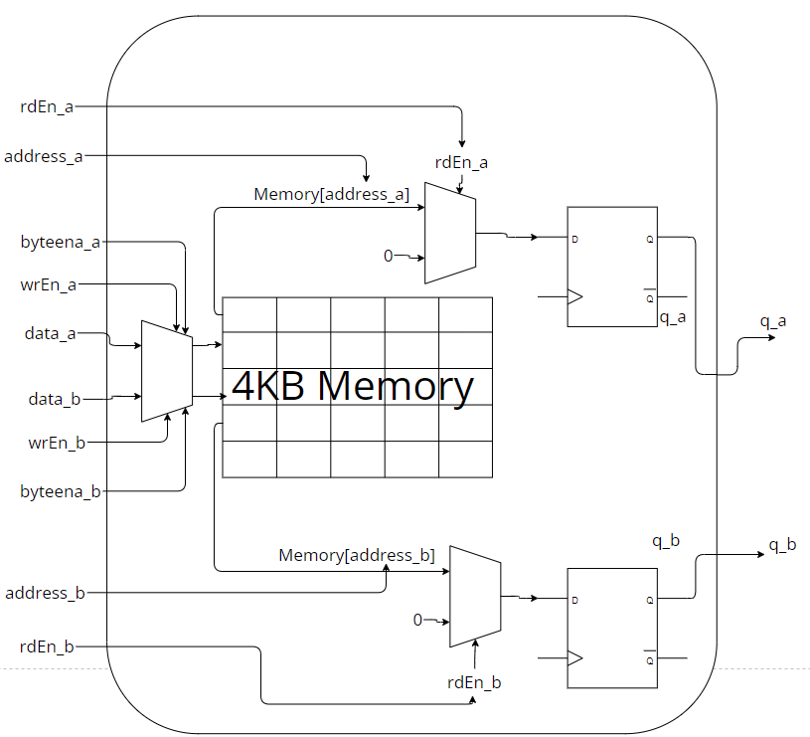

Figure - D Mem logic design

## CR_MEM

The CR (Control registers) Mem is a flip-flop-based memory module (unlike I mem and D mem which are S-RAM based). CR main purpose is to be the "controls" memory region. The module contains ports from the core and from the RC and contains 2 main sets of flops: Read Only and Read & Write flops. A logical "struct" contains a set of 1bit signals called Cr_En. Each of these signals is an "enable" signal for the many flops in the flops sets. For example Cr.En .pc_0 is the enable signal for the flop holds the Pc of thread0. When these signals turns to `0, the Pc0 flop holds the previous value.  
For the enable signals going to R&W flops, they get their value depends on the program running (if software accessed to "reset_pc_1" offset, the " Cr.En .pc_1" will set to `1). For those who connects to the R.O flops, they get their value from hardware.

The Read Only flops contains 22 flops that samples important system data (thread i's PC, current running thread number, current core, i mem and d mem MSB and many more). these R.O flops get their value from the hardware (for example the flops holding the current PC of a thread fed by input signal PcQ103H and the enable bit of the flop shuts down if the thread is in Freeze). **These flops cannot get data from the software** by no chance. If program ask to write data to R.O CR offset, nothing will happen.

An important CRs to mention are those which contains the stack base offset. In our validation plan, using the program, each thread accessed those CRs at the beginning of the program and saved the value as the stack base offset.

The Read & Write flops contains 24 flops that samples data coming from the software. 16 of these flops holds readable system data like the R.O flops but it can also changed by the software (for example change the stack base offset of a thread). The 8 other flops are also called "Core_CR". These flops can get the values `0 or `1 by the write data from program and those values going directly to the core and affects the behavior of it. For example if " core_cr.rst_pc_0" signal will set to `1, then by going to the core it will cause the Pc of thread0 to reset and go back to 0 value.

It’s important to mention that the **Ring gets priority on the Core** if both wants to write data to CR.

CR mem interface:

|  |  |  |  |
| --- | --- | --- | --- |
| ame | Size | Direction | Description |
| QClk | 1 | input | Clock signal |
| RstQnnnH | 1 | Input | Reset signal |
| CoreIdStrap | 8 | input | Id of the local core |
| Core Interface | | | |
| CrAddressQ103H | 32 | input | CR offset address coming from core |
| ThreadQ103H | 4 | input | Thread Id of the thread currently on stage Q103H |
| PcQ103H | 32 | input | Pc of the thread currently on stage Q103H |
| CrWrDataQ103H | 32 | input | data to be written by the core to CR Read & Write Flops |
| CrRdEnQ103H | 1 | input | read enable bit from the core |
| CrWrEnQ103H | 1 | input | write enable from the core |
| CrRdDataQ104H | 32 | output | data read from the CR Flops assign to the core |
| core_cr | 8 | output | CR data reaching the core for Pc functionality |
| RC interface | | | |
| F2C_AddressQ503H | 32 | input | CR offset address coming from RC |
| F2C_WrDataQ503H | 32 | input | data to be written by the RC to CR Read & Write Flops |
| F2C_CrRdEnQ503H | 1 | input | read enable bit from the Rc |
| F2C_CrWrEnQ503H | 1 | input | write enable from the Rc |
| F2C_CrRspDataQ504H | 32 | output | data read from the CR Flops assign to the RC |

Table 9 - Cr Mem interface

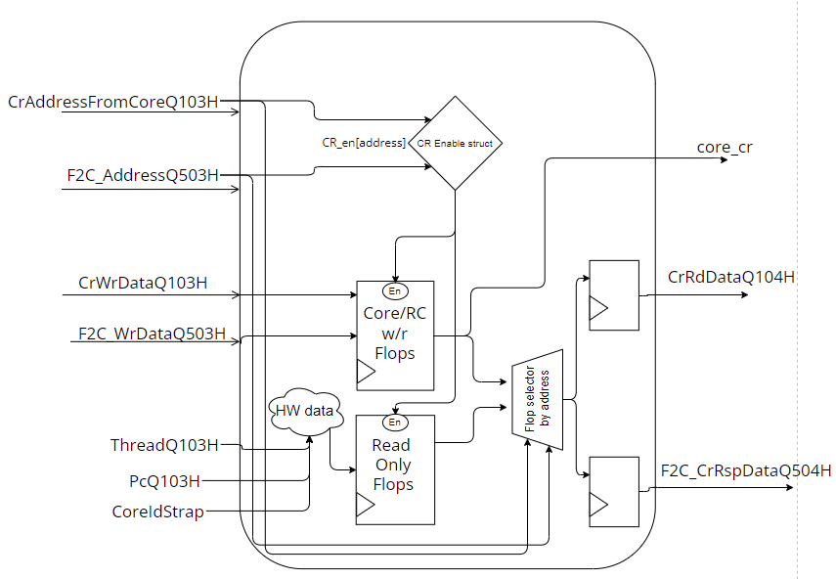

Figure - Cr Mem logic design

## D_MEM WRAP

The D MEM WRAP is the module wrapping and encapsulating the D Mem and the CR Mem modules. It's integrated to the core in the GPC_4T design and also to the Fabric. Using this module, the core can "talk" with the real data memory and the Control Registers memories, and this is the unit that connects with the core.  
Like the I MEM WRAP, this module instantiate the D MEM and the CR MEM modules, and also implements Fabric To Core logic for Ring controller interaction.  
Unlike the I MEM WRAP, the D MEM WRAP contains also a complex logic dedicate to handle Non-Local memory transactions. The core does not "know" about the ring and all the transactions are made by the D MEM Wrap.

D_MEM_WRAP Interface:

|  |  |  |  |
| --- | --- | --- | --- |
| Name | Size | Direction | Description |
| QClk | 1 | input | Clock signal |
| RstQnnnH | 1 | Input | Reset for all Flip Flops |
| CoreIdStrap | 8 | Input | ID of the source core |
| Core Interface | | | |
| ThreadQ103H | 4 | Input | Number of requesting thread |
| PcQ103H | 32 | Input | PC of the request instruction |
| CRQnnnH | 8 | output |  |
| AddressQ103H | 32 | Input | Request address |
| ByteEnQ103H | 4 | Input | Byte Enable according to Funct3 of the Opcode (LB/SB, LH/SH, LW/SW) |
| WrDataQ103H | 32 | Input | Data to be written |
| RdEnQ103H | 1 | Input | Identifying request as RD |
| WrEnQ103H | 1 | input | Identifying request as WR |
| MemRdDataQ104H | 32 | output | Data requested in Memory Access stage, retuned to Write Back stage |
| C2F_RspMatchQ104H | 1 | output | Signals to core about C2F response |
| T[i]RcAccess | 1 | output | signals to core if thread i accessed non local memory |
| Ring interface | | | |
| F2C_ReqValidQ503H | 1 | Input | Identifying valid Fabric Req |
| F2C_RspDMemValidQ504H | 1 | output | Identify as Rsp to the current GPC_4T |
| F2C_D_MemRspDataQ504H | 32 | output | Rsp data to the current GPC_4T |
| F2C_ReqOpcodeQ503H | 1 | Input | Fabric Req opcode |
| F2C_ReqAddressQ503H | 32 | Input | Fabric Req address |
| F2C_ReqDataQ503H | 32 | Input | Fabric Req data |
| C2F_RspValidQ502H | 1 | Input | Rsp to fabric validation bit |
| C2F_RspOpcodeQ502H | 1 | Input | Rsp to fabric opcode |
| C2F_RspThreadIDQ502H | 2 | Input | Destination thread |
| C2F_RspDataQ502H | 32 | Input | Rsp to fabric data |
| C2F_RspStall | 1 | Input | Currently NOT Implemented |
| C2F_ReqValidQ500H | 1 | output | Req validation bite from the current GPC_4T to a different GPC_4T in the ring |
| C2F_ReqOpcodeQ500H | 1 | output | Req opcode from the current GPC_4T to a different GPC_4T in the ring |
| C2F_ReqThreadIDQ500H | 2 | output | Req thread ID from the current GPC_4T to a different GPC_4T in the ring |
| C2F_ReqAddressQ500H | 32 | output | Req address from the current GPC_4T to a different GPC_4T in the ring |
| C2F_ReqDataQ500H | 32 | output | Req data from the current GPC_4T to a different GPC_4T in the ring (if opcode is Store) |

Table 10 - D MEM WRAP interface

Figure - D MEM WRAP logic design

as seen in the logic design figure, this module's logic is quite complicated. We'll try to simplify.

First There are the two instances of the D MEM and CR MEM modules:

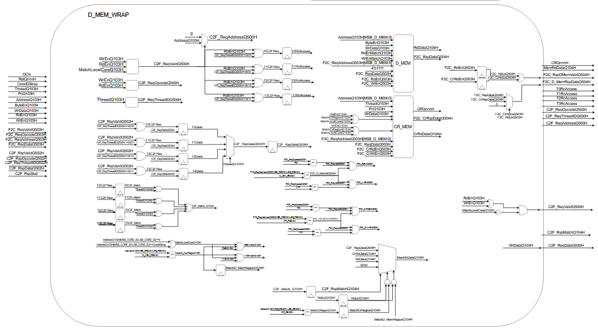

Each are fed by signals and data directly from the Core and the Fabric and by local logic signals.  
The Core's Read and write enable signals going to the instances, are toggled by the logic above. It must be a local core match and a valid D MEM address + read/write enable from the core.  
The Fabric request signals ( AKA F2C – Fabric to Core) coming also from the Fabric (By an F2C packet) and from local logic signals like the read and write signals for the Fabric:

Now we'll describe the logic dedicated to handle non-local memory requests and responses.   
The key signal is "MatchLocalCoreQ103H". If this signal set to `0, it means a request to non-local address came from the core (read or write) and a "C2F" packet (Core to Fabric) creates .

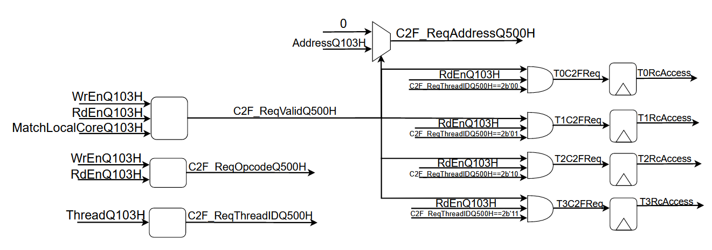

!

If it was a **write** request, the C2F request signals (C2F_ReqValidQ500H, C2F_ReqOpcodeQ500H, C2F_ReqThreadIDQ500H, C2F_ReqAddressQ500H, C2F_ReqDataQ500H) sent to the Fabric.

If **read** request, the complex logic comes to an action: 4 dedicated flops (one for each thread) holds the value `1 (depends on the thread) and send this signal to the Core, causing the PC of the thread to freeze as long as the signal is `1.  
the C2F request signals are sent to the Fabric.

When the C2F response arrives from the Fabric (the signals C2F_RspValidQ502H, C2F_RspOpcodeQ502H, C2F_RspThreadIDQ502H, C2F_RspDataQ502H), 4 flops (one for each thread) samples the C2F data coming from Fabric. Each flop will sample only if the response Thread (the thread who sent the request) is it – the enable signal of each flop toggled. For example T0 Data flop will sample and hold the C2F data if the C2F response is Valid and the ID of the thread requested is 0.   
A Mux determine the C2F data based on the current running thread( ThreadQ103H).

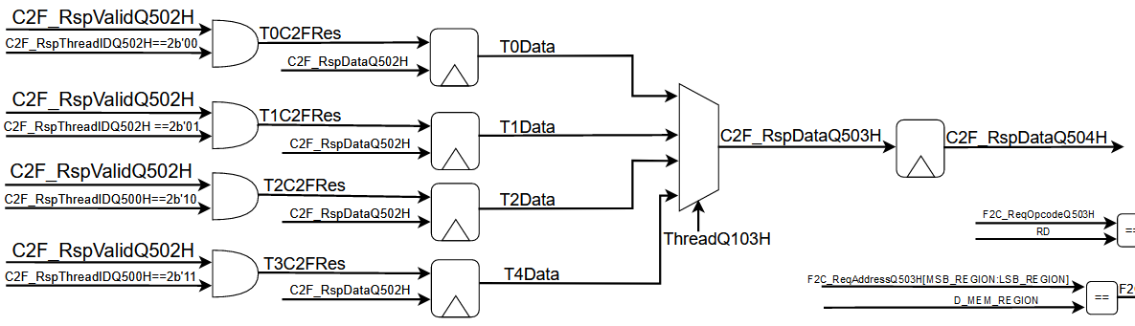

The response can come at any time. it means that if thread0 send request, the response can come when thread2 is currently running on Q103H. Therefore those 4 flops above will hold the data until the turn of the requested thread will come (and let's not forget that the thread is still on Pc Freeze).

For signaling and save the fact that the response arrived for the requested thread, and to release its Pc when its turn arrives, we used 4 dedicated flops holing the value `1 if response came.

Those flops will reset when the thread's turn arrives.  
When the requested thread's turn finally arrives, and the "C2F_Match_Q103H" signal is `1 implying that the data from the fabric is ready and this is the threads turn, a **reset signal** will send to the flops freezing the thread's PC and it will be Unfrozen.

The signal "MemRdDataQ104H" which is the signal sent to the Core and holds the memory read data, will be determine by the following priority based on the signals: C2F_Match_Q104H, MatchCrRegionQ104H, MatchD_MemRegionQ104H.  
 if "C2F_Match_Q104H", implying this is a data from non-local core, then the data sent to Core will be C2F_RspData. If not – the Cr Data. and last the local memory data.

# Design Flows

## Thread Freeze using CRs

One of the most special uses of the CRs is the ability to "freeze" thread's PC from another thread (or from the thread itself) and force the thread not to progress in the running program.  
This feature uses these CRs:

|  |  |  |  |
| --- | --- | --- | --- |
| Offset | Name | Type | Structure |
| 150 | THREAD<i>_PC_EN | RW | [0] |
| 154 |
| 158 |
| 15c |

Table 11 - CR offsets for thread freeze

Thread that wishes to freeze another thread's PC, will write '0' to the specific CR address.  
for example to freeze thread 2, '0' will be written to (0x00C00158) address.

Before explaining the flow, notice the Core implementation of the PC's:

Figure 23 - Pc enable code and logic

as seen in image, **T<X>EnPcQ100H** is the "Enable" for the PC flop. it affects if **Thread<x>** is currently running on Q102H and if **EnPCQnnnH[<x>]** is set to '1'. this signal effects by the **CRQnnnH** struct that enter the Core from the CR_MEM module. **If CRQnnnH.en_pc_X** is '0' then it means the Thread's PC will not progress (Enable for flip-flop is off). This is the signal that effects on whether the Thread's PC will freeze or not.

The Flow:

For simplicity let's say thread 0 wants to freeze thread's 2 PC.

1. Thread 0 Write's '0' to the address of the CR "CR_THREAD2_PC_EN" that is (0x00C00158).
2. On D_MEM_WRAP, "**MatchCrRegionQ103H**" turns to '1' due to accessing a CR address:  
   תמונה שמכילה טקסט, אלקטרוניקה, צילום מסך

   התיאור נוצר באופן אוטומטי
3. On CR_MEM, the address is decoded and a special struct called "cr_en" is assign in it designated field.   
     
   תמונה שמכילה טקסט

   התיאור נוצר באופן אוטומטי

Figure 24 - Cr enabler code

this struct contains many signals, each is an "Enable" signal for a different flip-flop.

1. The "enable" for a flip-flop that updates the values of the "core_cr" struct that will go to the core , turns to '1' and the value updates with the value of the data that written, in this case is '0' (**WrDataQ103H[SelWrDataQ103H.en_pc_2][0] = 0** ):  
     
   Chart, diagram, box and whisker chart

   Description automatically generated

Figure 25 - freeze Pc Cr flop to core logic

1. The "core_cr" struct go to the core with "core_cr. en_pc_2=0" and as explained before flow, the **CRQnnnH.en_pc_2** will be '0' and **EnPCQnnnH[2]** will also be '0' due to it, so the Enable bit for the Thread 2 PC will be off and Thread 2 will be "freeze".

## Thread Rst using CRs

One other feature of the CRs is the ability to reset thread's PC back to 0. This feature uses these CRs:

|  |  |  |  |
| --- | --- | --- | --- |
| Offset | Name | Type | Structure |
| 140 | THREAD<i>_PC_RST | RW | [0] |
| 144 |
| 148 |
| 14c |

Table 12 - CR offsets for thread reset

The flow is quite similar to the PC freeze flow explained before.  
Notice the implementation of the PC's flops in the core_4t module:

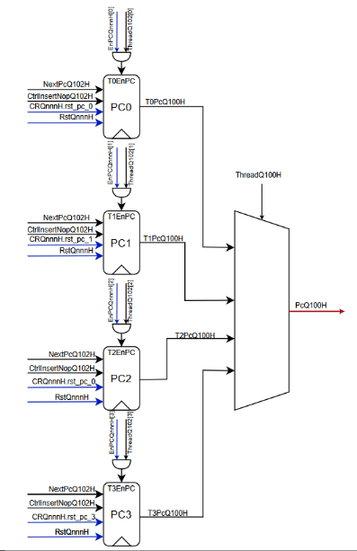

as seen in image, when the signal " **CRQnnnH.rst_pc_<X>**" is set to '1', the " T<X>PcQ100H" will be reset to 0.

The Flow:

For simplicity lets say thread 0 wants to reset thread's 2 PC.

1. Thread 0 Write's '1' to the address of the CR "CR_THREAD2_PC_RST" that is (0x00C00148).
2. On D_MEM_WRAP, "**MatchCrRegionQ103H**" turns to '1' due to accessing a CR address:  
   תמונה שמכילה טקסט, אלקטרוניקה, צילום מסך

   התיאור נוצר באופן אוטומטי
3. On CR_MEM, the address is decoded and the "cr_en" struct is assign in it designated field.   
     
   A picture containing chart

   Description automatically generated
4. The "enable" for a flip-flop that updates the values of the "core_cr" struct that will go to the core , turns to '1' and the value updates with the value of the data that written, in this case is '1' (**WrDataQ103H[SelWrDataQ103H.rst_pc_2][0] = 1** ):  
     
   Diagram

   Description automatically generated

Figure 26 - reset Pc Cr flop to core logic

1. The "core_cr" struct go to the core with "core_cr. rst_pc_2=1" and as explained before flow, **CRQnnnH.rst_pc_2** will be '1' and " **T2PcQ100H**" will be reset back to 0

## Multi Thread Support (Single 4 Thread Core)

In the design, there is a single instruction memory which the core reads instruction from. Therefore all 4 threads reading the same program.  
The solution we found to run multithread applications is to use a dedicated CR register known as “CR_THREAD” which is located by the offset 0x4 on the CR address space ( full address 0x00C00004).  
This flop is a read only flop contains the Id of the current thread running on stage Q103H (memory access stage).

* Each thread reads this CR’s value and then can use direct branch to jump a dedicated section of the program
* Each thread now initiates separate section of the code (for example different function)
* When a thread finished its section, it will perform a busy wait :
  + first signal the other threads it finished (by writing `1 to a sheared memory address or CR scratchpad for example)
  + Later waits for other threads signals.
* First thread to finish the busy wait, terminates the program.  
  A detailed example in the Validation Plan.

## Writing to Non-Local Memory

As explained, data can be written to another Core's memory using the C2F buffer of the Ring Controller.   
  
For simplicity let's say thread 1 wants to write data on the address 0x02000200

The Flow:

1. Thread 1 send write request with data to the address : (0x02000200) .
2. in the D_MEM_WRAP:
   1. a signal called " MatchLocalCoreQ103H" is set to '0' because of the 10 MSB digits (which are called “core ID”) in the address indicates this address is not in the local core.
   2. C2F packet is assembled:

|  |  |  |
| --- | --- | --- |
| packet signal | description | value |
| C2F_ReqValidQ500H | 1 if MatchLocalCoreQ103H=0 and we have "write enable" | 1 |
| C2F_ReqOpcodeQ500H | type of C2F request | WR |
| C2F_ReqThreadIDQ500H | the thread requested the transaction | 01 |
| C2F_ReqAddressQ500H | address to be accessed | 0x02000200 |
| C2F_ReqDataQ500H | data to be written | [31:0] of data |

Table 13 - C2F write request packet

1. The packet signals are sent to the Ring Controller which will allocate a “C2F” Buffer Entry.  
   eventually The C2F Requests will exit our “Tile” towards the Fabric.
2. The packet arrives to the designated Tile (Core Id = 02) and will allocate a “F2C” Buffer Entry.  
   Eventually the RC buffer will send the requests to the core. using the F2C_Req Interface to the D MEM WRAP and the data immediately written on this (Core 2) core memory.

It can be notice that for the requester, it’s not different from a local memory write request – fire and forget.

Figure 27 - C2F packet signals code

## Reading from Non-Local Memory

As explained in HAS, data can be read from another Core's memory using the C2F buffer of the Ring Controller.  
The special thing about this read request, is that when a thread from the local core sends the request, its PC is frozen until the respond with the read data arrives from the ring controller. This could take some clock cycles depends on the number of cores.

For simplicity let's say **thread 1** wants to read data on the address 0x02000200

The Flow:

1. Thread 1 send read request to the address: (0x02000200)
2. in the D_MEM_WRAP:
   1. a signal called " MatchLocalCoreQ103H" is set to '0' because of the 10 MSB digits (Core ID) in the address indicates this address is not in the local core.
   2. C2F packet is assembled:

|  |  |  |
| --- | --- | --- |
| packet signal | description | value |
| C2F_ReqValidQ500H | 1 if MatchLocalCoreQ103H=0 and we have "read enable" | 1 |
| C2F_ReqOpcodeQ500H | type of C2F request | RD |
| C2F_ReqThreadIDQ500H | the thread requested the transaction | 01 |
| C2F_ReqAddressQ500H | address to be read data from | 0x02000200 |
| C2F_ReqDataQ500H | data to be written |  |

Table 14 - C2F read request packet

* 1. A signal called " T1C2FReq" will be set to 1
  2. A flip-flop with output signal "T1RcAccess" will be sampled with "1" as the " T1C2FReq" signal is used as the Enable bit for the flop.
  3. " T1RcAccess" is an output to the Core. Diagram, schematic

     Description automatically generated
  4. in the later cycles, the signal T1C2FReq is set to '0' and the flip flop is locked with the value T1RcAccess = '1'.
  5. The packet signals are sent to the Ring Controller which will allocate a “C2F” Buffer Entry.  
     eventually The C2F Requests will exit our “Tile” towards the Fabric

1. In the core, the signal " T1RcAccess" shuts down the enable bit for Thread 1 and freeze it.
2. The packet goes thru the RC and arrives to the designated core (Core Id = 02) with the RC inputs to the D MEM WRAP and the data immediately read from this core memory to the signal "F2C_RspDataQ504H".
3. The packet data send to the Ring Controller and in the RC design it transformed to an C2F respond packet.
4. thru all this time the thread sends the read request is on freeze.
5. In D MEM WRAP:  
   1. When C2F Response packet arrived (the signal C2F_RspValidQ502H='1') a C2F response packet assembled:

|  |  |  |
| --- | --- | --- |
| packet signal | description | value |
| C2F_RspValidQ502H | comes as an input from RC | 1 |
| C2F_RspThreadIDQ502H | the thread requested the original transaction | 01 |
| C2F_RspDataQ502H | data that read | some data |

Table 15 - C2F response packet

* 1. A signal "T1C2FRes" set to '1' and that signal uses as the Enable bit for a flip-flop that samples the "C2F_RspDataQ502H" data on a signal called "T1Data". in the next cycle the T1C2FRes is set to '0' and "T1Data" is locked on the value that "C2F_RspDataQ502H" was when the packet arrived. this feature is used in order to save this data until the turn of the thread that sent the original read request comes.
  2. When the thread's turn arrives, a signal named "C2F_RspDataQ503H" get the data from "T1Data" and will sampled to "C2F_RspDataQ504H".  
     Diagram

     Description automatically generated
  3. another signal named " T1C2F_Match" is sampled to '1' by another flop with Enable bit as "T1C2FRes" like the previous flop. Diagram, schematic

     Description automatically generated
  4. Signal named "C2F_Match_Q103H" will set to '1' when "T1Data"='1' and the running thread is thread 1. When the thread turns arrived, this signal will indicate the D MEM WRAP output signal " MemRdDataQ104H" to take the value of "C2F_RspDataQ504H".
  5. Signal named "RstT1RcAccess" will set to '1' when "C2F_Match_Q103H" is '1' and the current thread is thread 1. this signal will reset the flip flop with output signal "T1RcAccess" back to '0' and this will release thread 1 from Freeze and its PC will continue.
  6. " MemRdDataQ104H" signal will be transferred to the core with the data read from another core.